**Molchanov Semen ID 20B030231**

Laboratory work 1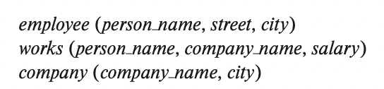

**Please write your answers to the pdf ﬁle for defense:**

1. Consider the employee database of ﬁgure below. Give an expression in the relational algebra to express each of the following queries:

**Figure**

Remark: all of this works if in relations “employee” and “works” we have the attribute ID that describes each person’s unique ID

•Find the ID and name of each employee who works for “BigBank”.

((employeeworks))

•Find the ID, name, and city of residence of each employee who works for “BigBank”.

((employeeworks))

•Find the ID, name, street address, and city of residence of each employee who works for “BigBank” and earns more than $10000.

((employeeworks))

•Find the ID and name of each employee in this database who lives in the same city as the company for which she or he works.

(employeecompany))

2. Consider the employee database of ﬁgure above. Give an expression in the relational algebra to express each of the following queries:

•Find the ID and name of each employee who does not work for “ BigBank”.

((employeeworks))

•Find the ID and name of each employee who earns at least as much as every employee in the database.

((works), where average_salary = arithmetic mean of salaries in database

3. Consider the foreign-key constraint from the dept_name attribute of instructor to the department relation. Give examples of inserts and deletes to these relations that can cause a violation of the foreign-key constraint.

Deleting attribute dept_name from “department” relation can cause a violation of the foreign-key constraint since now dept_name attribute in “instructor” relation references nothing. Also it ruins the logic of the “department” relation: now, since it also has no ID attribute, it doesn’t have the main describing information – it’s name which could be primary key in this relation

4. Consider the employee database of ﬁgure above. What are the appropriate primary keys?

If we suppose that relation “employee” has attribute “ID” as it should be, then we say that “ID” is an appropriate primary key, since it describes unique tuple of each possible relation